CS Bridge Module 10 Strings

1. Strings

1.1 CS Bridge: Strings

Notes:

1.2 Introduction

Notes:

1.3 Initializing Strings
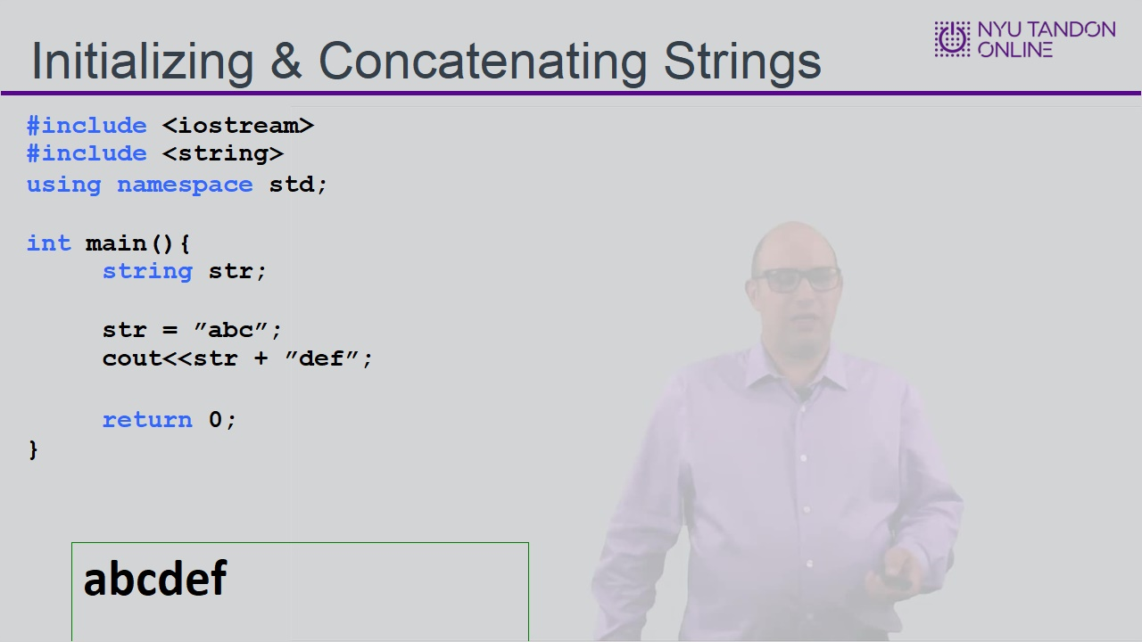
Notes:

1.4 Reading Strings
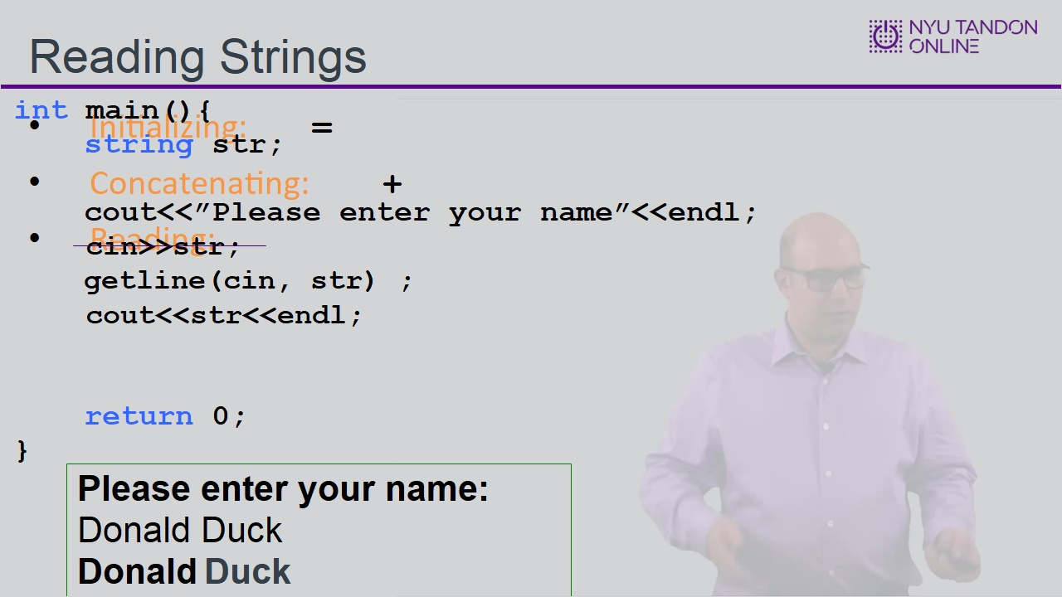

1.5 Knowledge Check
(Multiple Choice, 10 points, 1 attempt permitted)
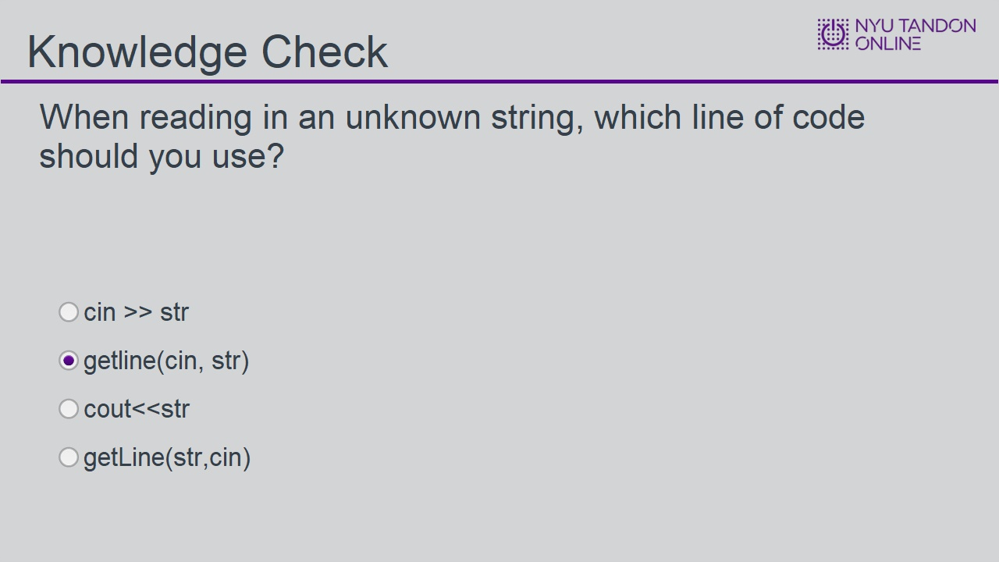
Correct | Choice | Feedback
 | cin >> str | If the string is more than one word, only the first word will be read in, and the rest will be lost.
X | getline(cin, str) | Correct! getline allows you to read in a string regardless of how many spaces are in it
 | cout<<str | Not quite! cout is how to print a string, not how to read in a string!
 | getLine(str,cin) | This is not a valid function call. Note that the names of standard C++ functions are all in lowercase.

cin >> str (Slide Layer)
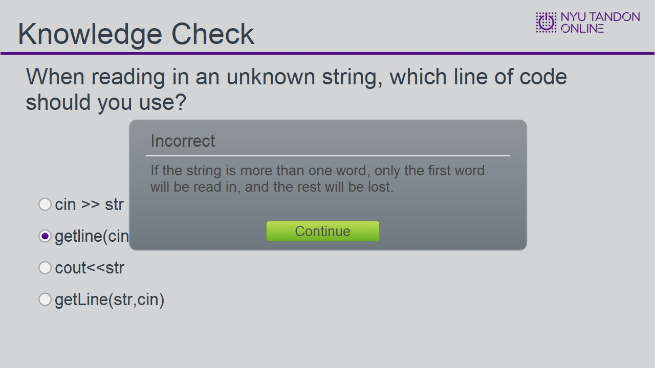

getline(cin, str) (Slide Layer)
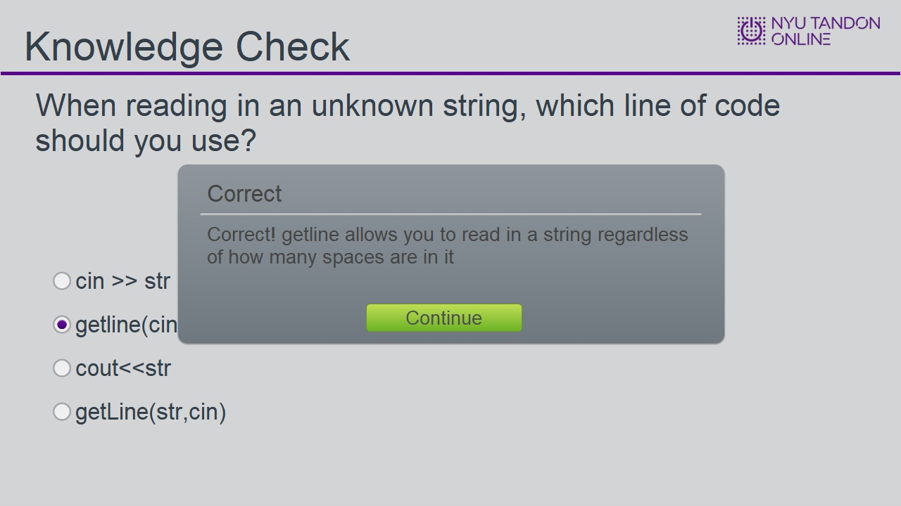

cout<<str (Slide Layer)
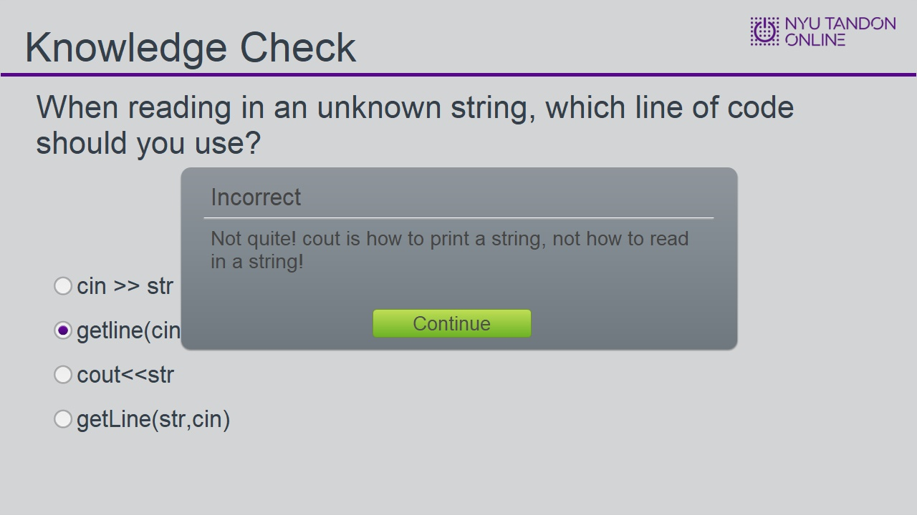

getLine(str,cin) (Slide Layer)
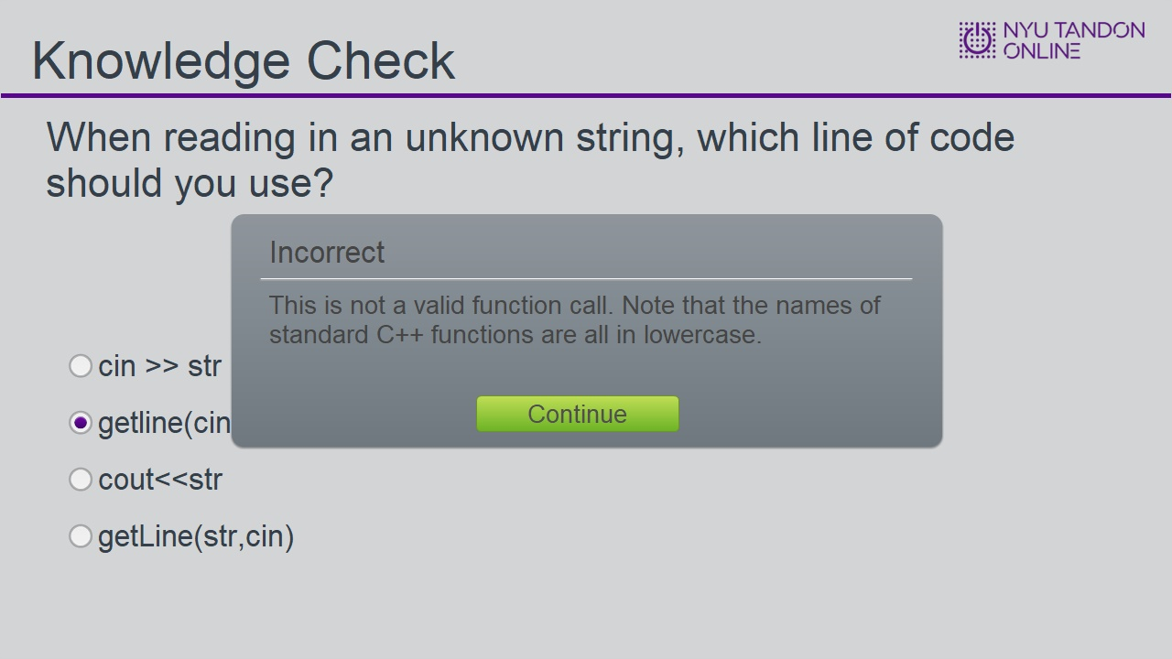

1.6 Indexing Strings
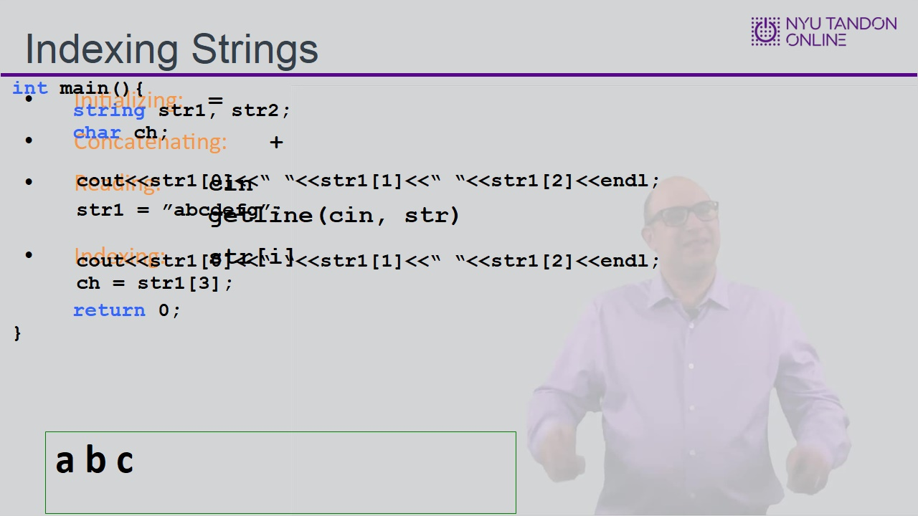

1.7 Slicing Strings
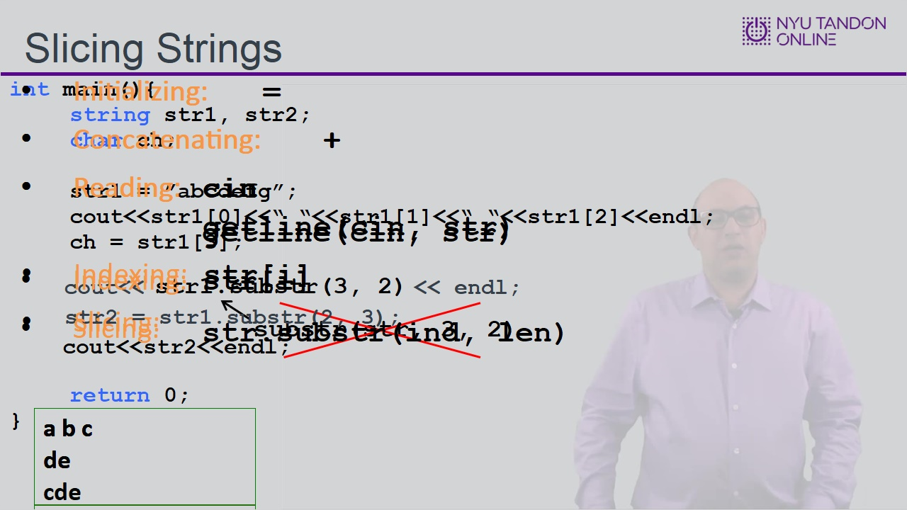

1.8 Length
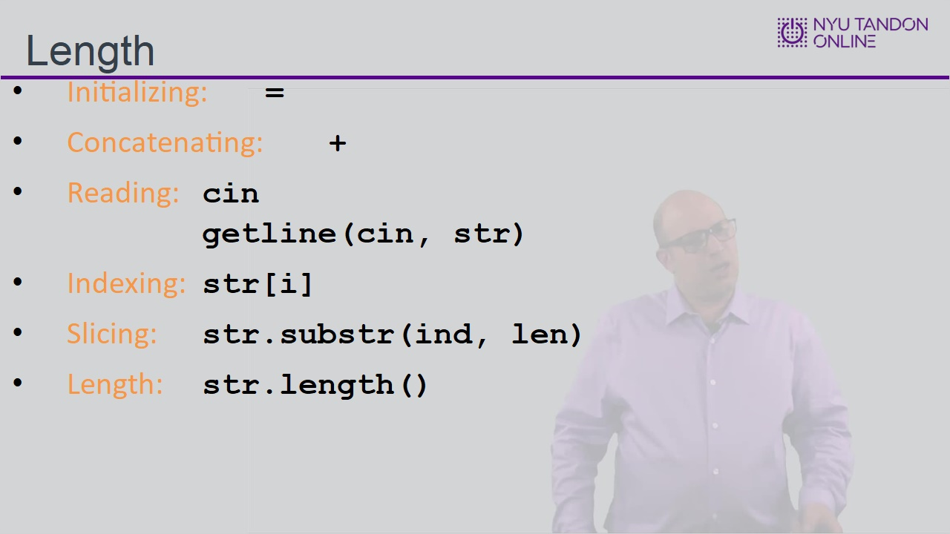

1.9 Printing Backwards Introduction
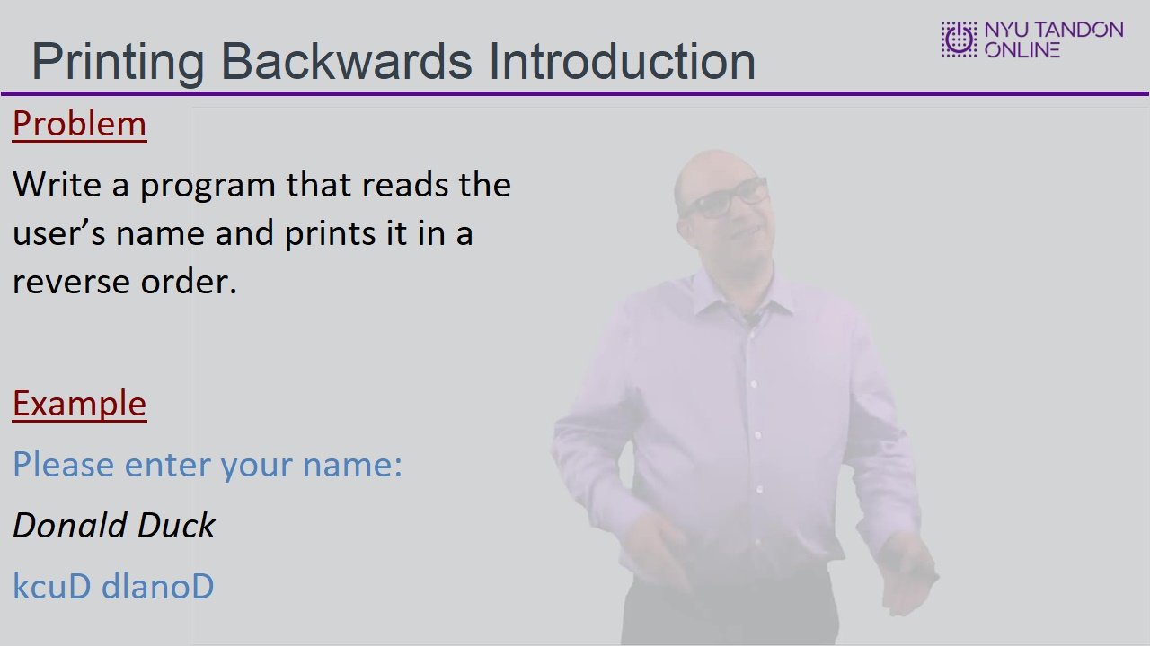

1.10 Printing Backwards Implementation
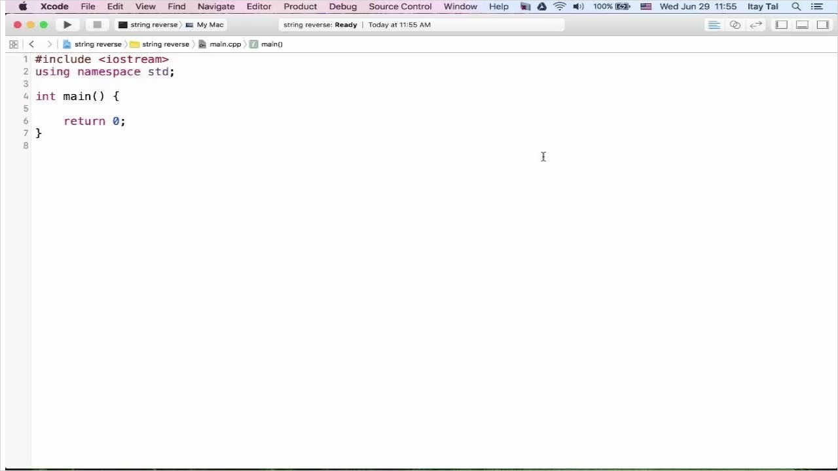

1.11 Comparing Strings
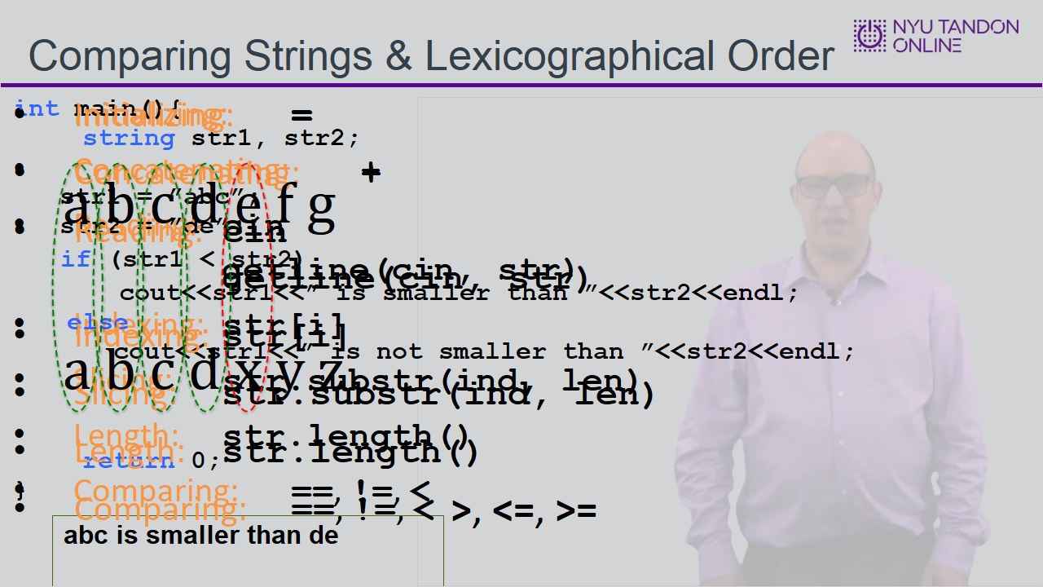
Notes:

1.12 First Word Introduction
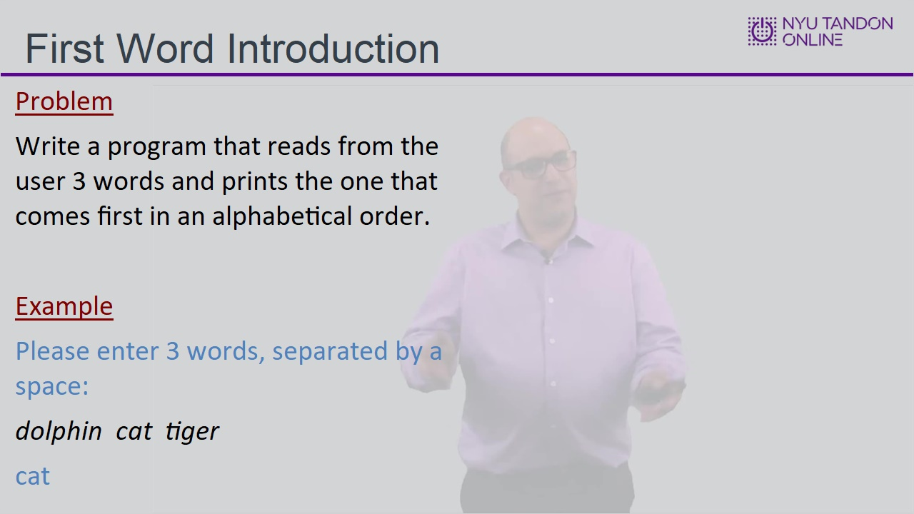

1.13 First Word Walkthrough
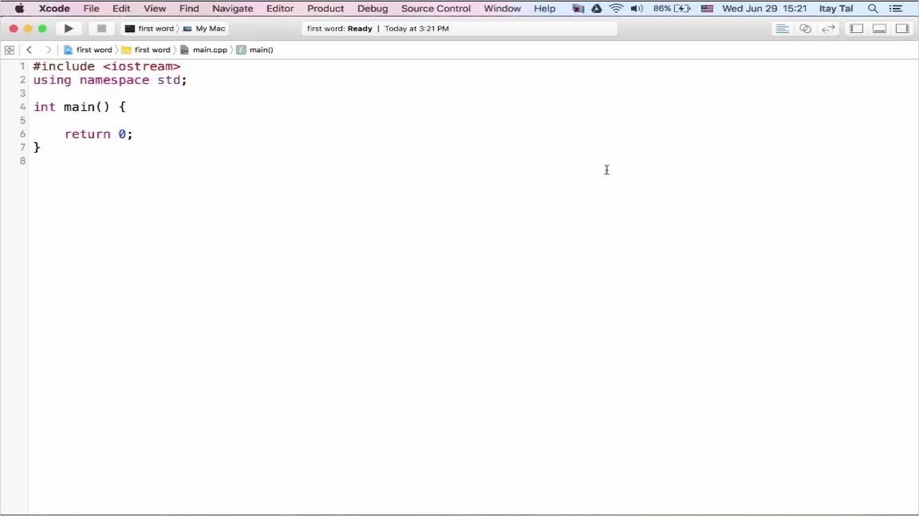

1.14 Searching in a String
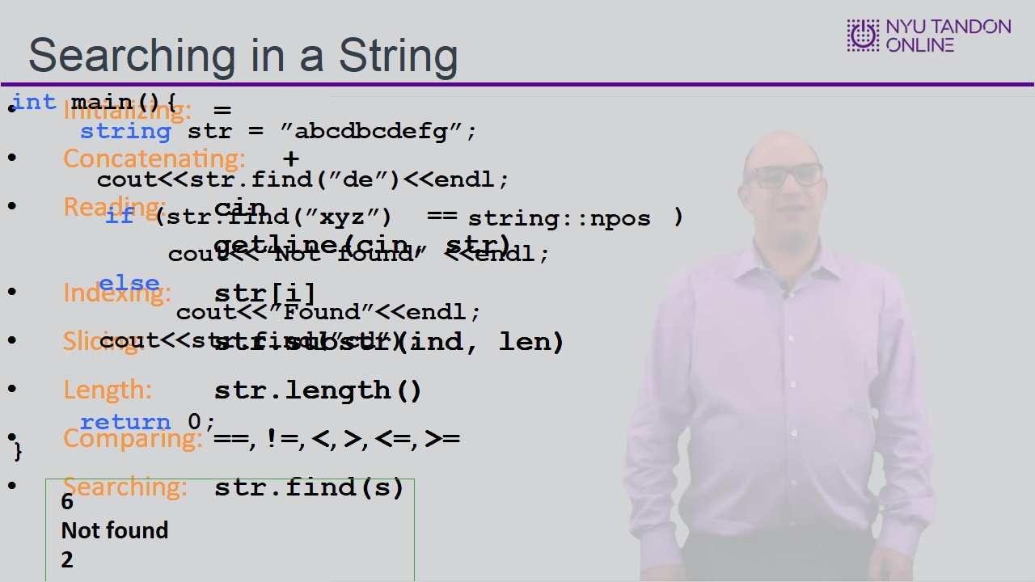

1.15 Starting Index
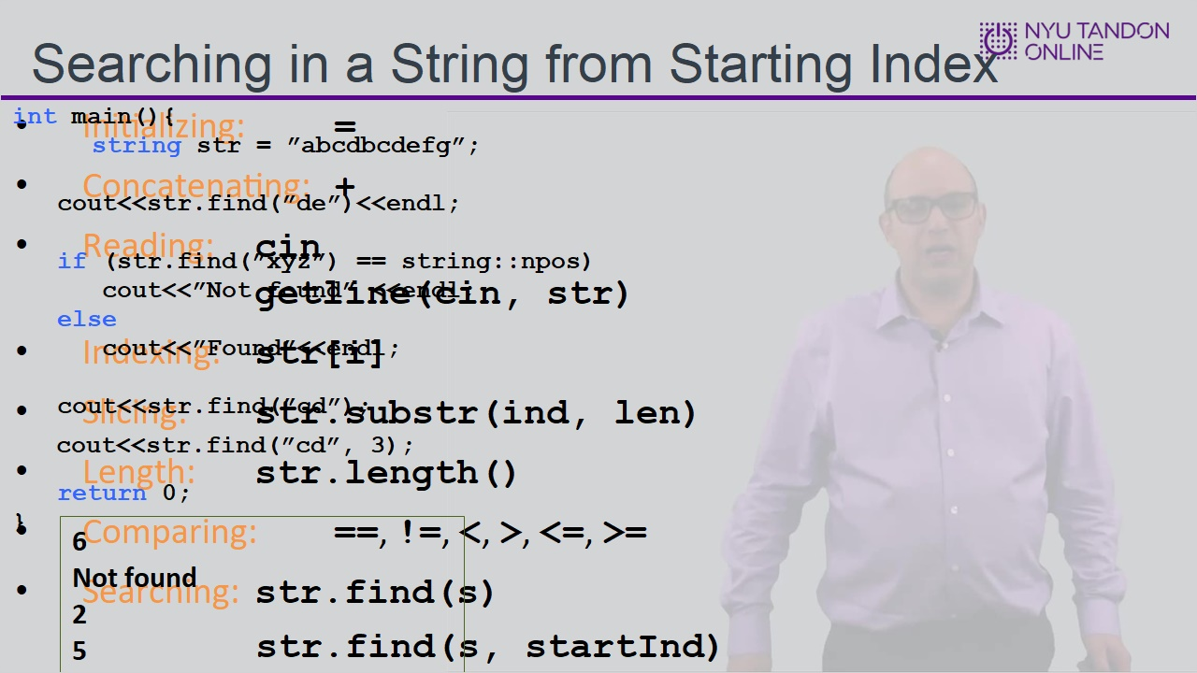

1.16 Knowledge Check
(Matching Drag-and-Drop, 10 points, unlimited attempts permitted)
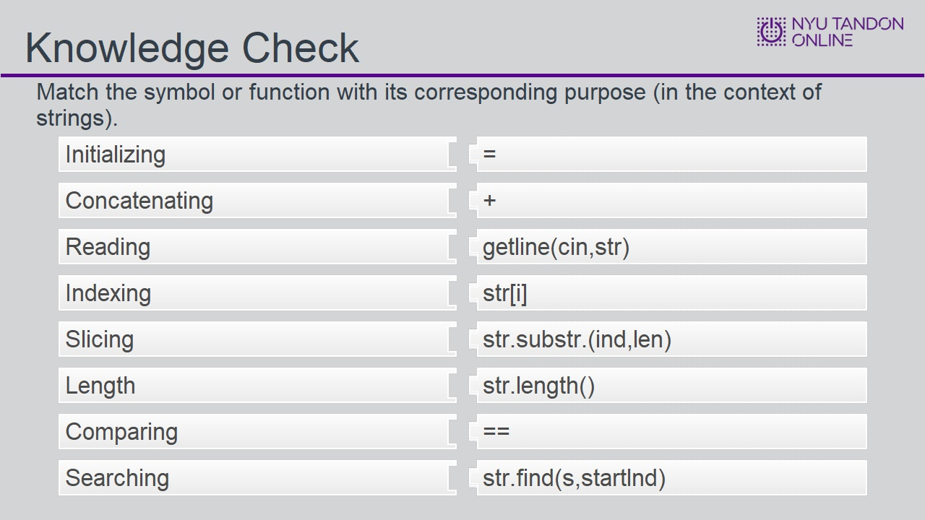
Correct | Choice
Initializing | =
Concatenating | +
Reading | getline(cin,str)
Indexing | str[i]
Slicing | str.substr.(ind,len)
Length | str.length()
Comparing | ==
Searching | str.find(s,startlnd)

Feedback when correct:
That's right! You selected the correct response.

Correct (Slide Layer)
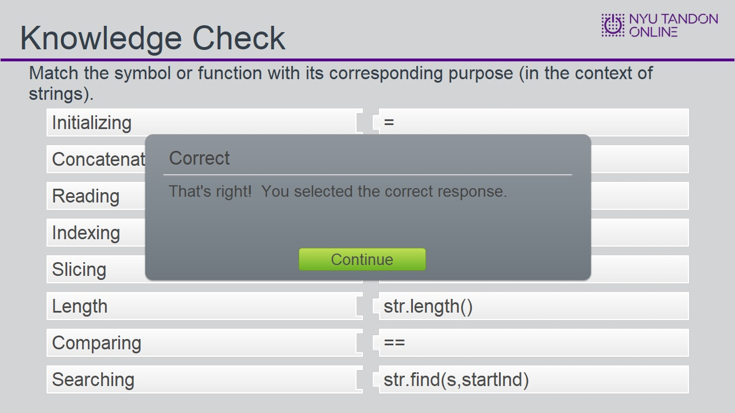

Try Again (Slide Layer)
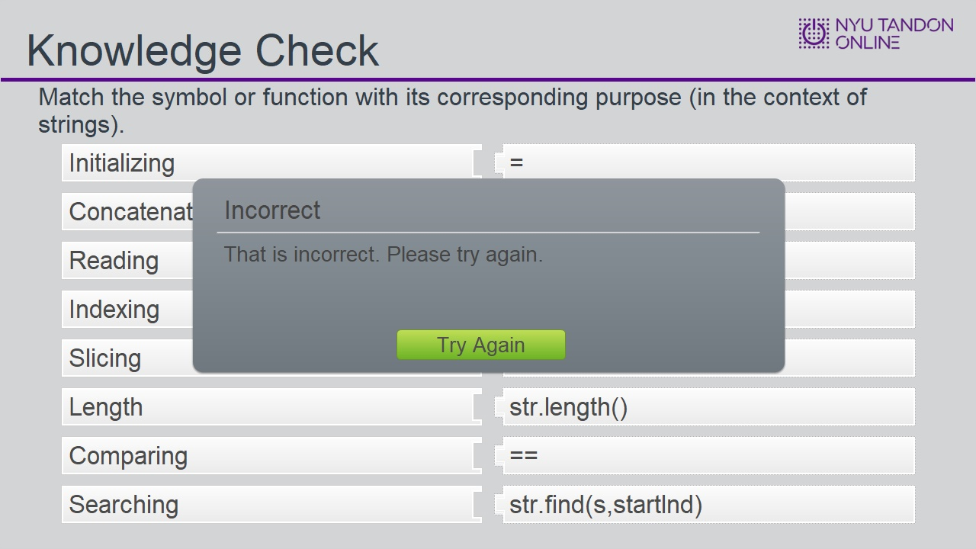

1.17 End of Module


